Microcontroller Intial Research
Microcontrollers + Current Waveform Generators Stats Sheet + Feasibility

Current Waveform Generators Spec Sheets
Modern waveform generators can produce a wide variety of waveforms, including sine, square, triangle, ramp, arbitrary, and noise signals. Typical output amplitudes range from millivolts up to about 20 V peak-to-peak, often with adjustable DC offset. High-end devices can generate sine waves up to hundreds of megahertz, while square and triangle waves are generally limited to tens of megahertz due to rise-time constraints. Many models support multiple synchronized channels, precise phase control, and programmable sequences, making them highly versatile for testing, simulation, and signal generation in electronics and communications applications.

Model | Max Frequency (Sine) | Max Frequency (Square) | Max Frequency (Triangle) | Max Amplitude (pp) | Waveform Types
Siglent SDG2122X | 120 MHz | 25 MHz | Not specified | 20 Vpp (High-Z) | Sine, Square, Triangle, Arbitrary
Siglent SDG5000 Series | 160 MHz | 50 MHz | Not specified | Not specified | Sine, Square, Triangle, Arbitrary
AWG-4150 | 50 MHz | 25 MHz | Not specified | Not specified | Sine, Square, Triangle, Pulse, Noise
Keithley 3390 | 50 MHz | 25 MHz | Not specified | Not specified | Sine, Square, Triangle, Arbitrary
BK Precision 4060 Series | 25 MHz | 25 MHz | 5 MHz | Not specified | Sine, Square, Triangle, Pulse, Arbitrary

Feasibility
For our project, I believe we should aim to design a reasonably capable DIY function generator that can produce sine, square, and triangle waveforms with a maximum frequency of 5 MHz and an output amplitude of up to 10 V peak-to-peak. It should also be capable of adjusting the amplitude and offset of the voltage. To achieve this, we plan to use a DDS-based architecture with a suitable DAC and an amplification stage to reach the desired voltage range. There are many resources and examples online of people implementing similar systems to this and achieving similar results.

Microcontrollers
MCU: Decides “what waveform, what frequency, what amplitude.”
FPGA: Uses phase accumulator + tuning word + waveform memory to generate the digital waveform in real time for the DAC.
DAC: Converts those digital samples to analog.
Amplifier/Filter: Scales and smooths the output.

The microcontroller (MCU) acts as the interface between the user and the waveform generation system. It receives commands from the app (like waveform type, frequency, and amplitude), parses them, and calculates the tuning words that control the phase accumulator in the FPGA or DDS chip. Essentially, the MCU handles user interaction, computation, and configuration, while leaving the high-speed waveform generation to the FPGA/DAC.

Potential Microcontrollers:

Microcontroller | Dual-Channel Control | Wireless | Pros | Cons
ESP32 | ✅ | ✅ Built-in Wi-Fi & Bluetooth | Affordable (~$5–$10), easy app integration, sufficient processing for tuning words, large community support, dual-core CPU | Limited RAM (~520 KB), onboard DACs too slow for 5 MHz signals (requires external DAC/DDS)
STM32F4 / STM32F7 | ✅ | Optional (requires external Wi-Fi/BLE module) | High-speed Cortex-M4/M7 CPU (168–216 MHz), DMA support for fast data streaming, multiple SPI/I2C ports | Requires external wireless module for app communication, steeper learning curve
Teensy 4.1 | ✅ | Optional (requires external Wi-Fi/BLE module) | Extremely fast (600 MHz), lots of RAM for arbitrary waveforms, multiple SPI/I2C interfaces | More expensive (~$20–$25), external wireless module needed, slightly more complex integration
Arduino Due (ATSAM3X8E) | ✅ | Optional (requires external Wi-Fi/BLE module) | Easy to program with Arduino IDE, has onboard 12-bit DACs | Slower CPU (84 MHz) — may struggle with precise 5 MHz waveform updates, limited RAM, external wireless module needed

What I think will be best : ESP32. The microcontroller will not need to be super fast because the FPGA will handle the high speed aspects. The ESP32 has built in wifi and bluetooth too which will reduce the complexity of having to add an external module for this. Lushner is also familiar and would be able to assist with this MCU.

Microcontroller Parameters

1. Parameters MCU Receives

From Phone/App (via BLE or WIFI)
These come from the user:
- Waveform type → sine, square, triangle, arbitrary (enum).
- Frequency → requested output frequency (0 Hz – 5 MHz).
- Amplitude (Vpp) → requested peak-to-peak voltage.
- Offset (Vdc) → requested DC shift in volts.
- Phase → requested phase in degrees (0–360).
- Arbitrary waveform data (if AWG mode chosen) → sample bytes streamed into FPGA RAM.
- Control commands → APPLY, QUERY status, RESET, etc.

From FPGA/DDS subsystem
Status/handshake signals:
- FPGA_READY (digital input) → FPGA can accept a new control frame.
- FPGA_BUSY (digital input, optional) → FPGA is updating internals, don’t send.
- FPGA_IRQ (digital input, optional) → FPGA signals an error (overflow, CRC fail, etc.).

From DAC/Analog subsystem (optional, only if directly wired)
- Fault/status pins → overrange, thermal shutdown, reference error.
- Reference monitor → internal/external ref OK flag.

2. Parameters MCU Sends

To FPGA/DDS subsystem (via SPI + GPIO pulse)
These are the translated control words the FPGA actually needs:
- Frequency Tuning Word (FTW) → 32-bit, computed as
FTW = round(f_out * 2^32 / f_clk)
- Amplitude word → 16-bit digital gain (scales waveform before DAC).
- DC offset word → 16-bit signed digital offset.
- Phase word → 16-bit (0–65535 = 0–360°).
- Waveform select code → enum (sine, square, tri, arb).
- Flags → APPLY_NOW, select AWG bank, etc.
- Arbitrary waveform memory contents → streamed sample data (when AWG mode).
Sent as a 20-byte control frame, then latched with MCU_UPDATE pulse.

To DAC subsystem (if configured directly, bypassing FPGA)
- Reference configuration (internal vs. external voltage ref).
- Calibration/offset trims.
- Power-down or reset signals.

To Phone/App (BLE Notifications)
- Acknowledgements → “CMD received, applied”.
- System status → “Generating SINE, 1.000000 MHz, 2.0 Vpp, 0.0 V offset”.
- Error reports → “Invalid frequency > 5 MHz”, “FPGA CRC error”, “DAC fault”.

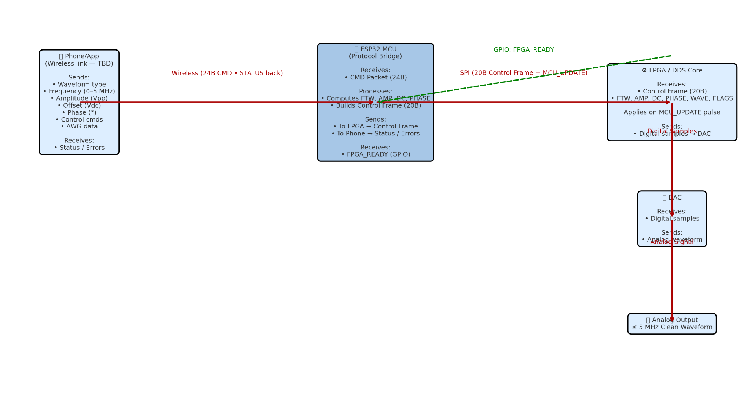

DAQ Research
DAQ Requirements
- 1 MSA/s or greater (need to also consider settling time for this)
- Buffered voltage output is best for our needs. Current output or unbuffered output adds more complexity
- SOIC or DIP package

Potential DAC’s

DAC8581 (TI)

https://www.ti.com/product/DAC8581

Pros
- 16 bit, 3MSPS, 0.65 uS settling time (Real sampling rate of just under 2MSPS)
- Buffered voltage output of plus minus 5v
- Capable of driving 50 ohm loads as long as current doesn’t exceed 25mA
- Waveform generation listed in applications

Cons
- Older
- 50 ohm loads will reduce voltage from plus minus 5 volts
- Could practically drive 50 ohm loads at +-1 V, (amplfier, not sure what to do in this case)
- SOP package

DAC8831 (TI)

https://www.ti.com/product/DAC8831/part-details/DAC8831ICD?utm_source=google&utm_medium=cpc&utm_campaign=asc-null-null-asc_opn_en-cpc-storeic-google-ww_en_pur&utm_content=Device&ds_k=DAC8831ICD&DCM=yes&gclsrc=aw.ds&gad_source=1&gad_campaignid=8178396718&gbraid=0AAAAAC068F2G4xxhiWs9syzdttDmSrPzA&gclid=Cj0KCQjwoP_FBhDFARIsANPG24Mwu6B4nwbIs-2K-sPdUQNeGtQeo03dbyRKTJLbKK6Y_gslbBDrmO8aAq81EALw_wcB

Pros
- Similar specs in terms sample rate and settling time
- SOIC package can buy adapter to get DIP package

Cons
- Unbuffered Adds complexity
- Need external OPA OPA2140

Current output DACs are designed to output a digitally-controlled current into the "virtual ground" presented by the inverting input of an external opamp. Usually, current output DACs also provide a feedback resistance for the opamp which compensates for any resistance tempco of the DAC's R/2R output ladder. Most current output DACs are also what we call multiplying DACs, because they are designed so that they can be used with either positive or negative voltage reference inputs or even an AC reference voltage input, in which case they can be used as "digital volume controls."

Voltage output DACs have the amplifier built-in, and do exactly as their name implies: they output a digitally-controlled voltage. Usually they are restricted to a positive-only reference input.

Which one to use? Depends on whether you need the flexibility and versatility of the current-output DAC, or need the low overall component count of the voltage-output DAC.

If you want to understand current-output DACs a bit more, here's a link to the page for the LTC8043, which I use frequently:

Parallel DACS

TI DAC8820
chrome-extension://efaidnbmnnnibpcajpcglclefindmkaj/https://www.ti.com/lit/ds/symlink/dac8820.pdf?ts=1758563825816&ref_url=https%253A%252F%252Fwww.ti.com%252Fproduct%252FDAC8820%253Futm_source%253Dgoogle%2526utm_medium%253Dcpc%2526utm_campaign%253Dasc-null-null-GPN_EN-cpc-pf-google-ww_en_cons%2526utm_content%253DDAC8820%2526ds_k%253DDAC8820%2526DCM%253Dyes%2526gclsrc%253Daw.ds%2526gad_source%253D1%2526gad_campaignid%253D14388345080%2526gbraid%253D0AAAAAC068F16ojdJ9MNxrP3IcDVHBK5Wt%2526gclid%253DCj0KCQjw58PGBhCkARIsADbDilywxGPcHJchOuRc0pGcefwMA3Fr3j6XV2tRrOsrH6vhsDEgR3tbjZQaAo42EALw_wcB
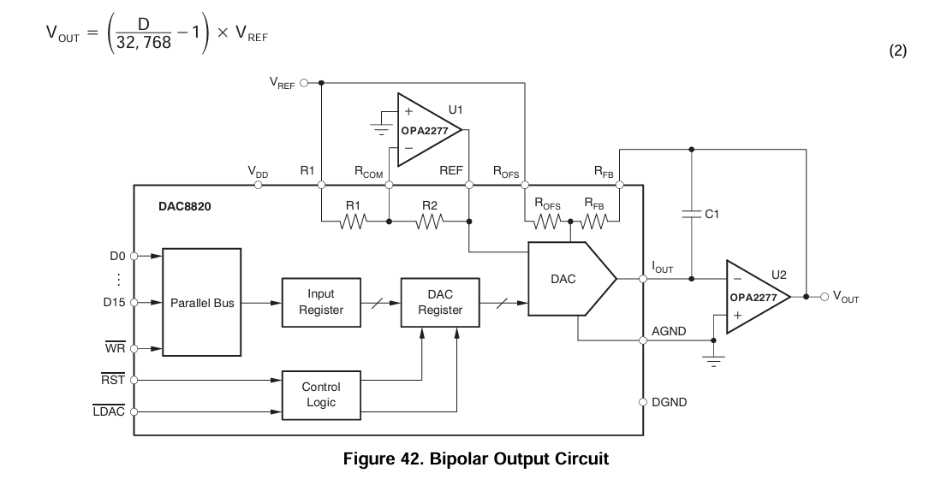

Need faster slew rate than OPA 2277. OPA1612 output. OPA2140 for reference
https://www.mouser.com/ProductDetail/Texas-Instruments/OPA1612AID?qs=6805eV47HhZ33ht61fXkkg%3D%3D&utm_id=22380207736&utm_source=google&utm_medium=cpc&utm_marketing_tactic=amercorp&gad_source=1&gad_campaignid=22376567996&gbraid=0AAAAADn_wf37ELSYQpy-1rLZ41Dfle14f&gclid=Cj0KCQjw58PGBhCkARIsADbDilxBTY1jFxFl0THzaVQz5J4xVIZU-cgLCup2BPfYnra1o4evOU42gWMaAo5IEALw_wcB

https://www.mouser.com/ProductDetail/Analog-Devices/LTC1668CGPBF?qs=hVkxg5c3xu9lP9hBlG4Wow%3D%3D
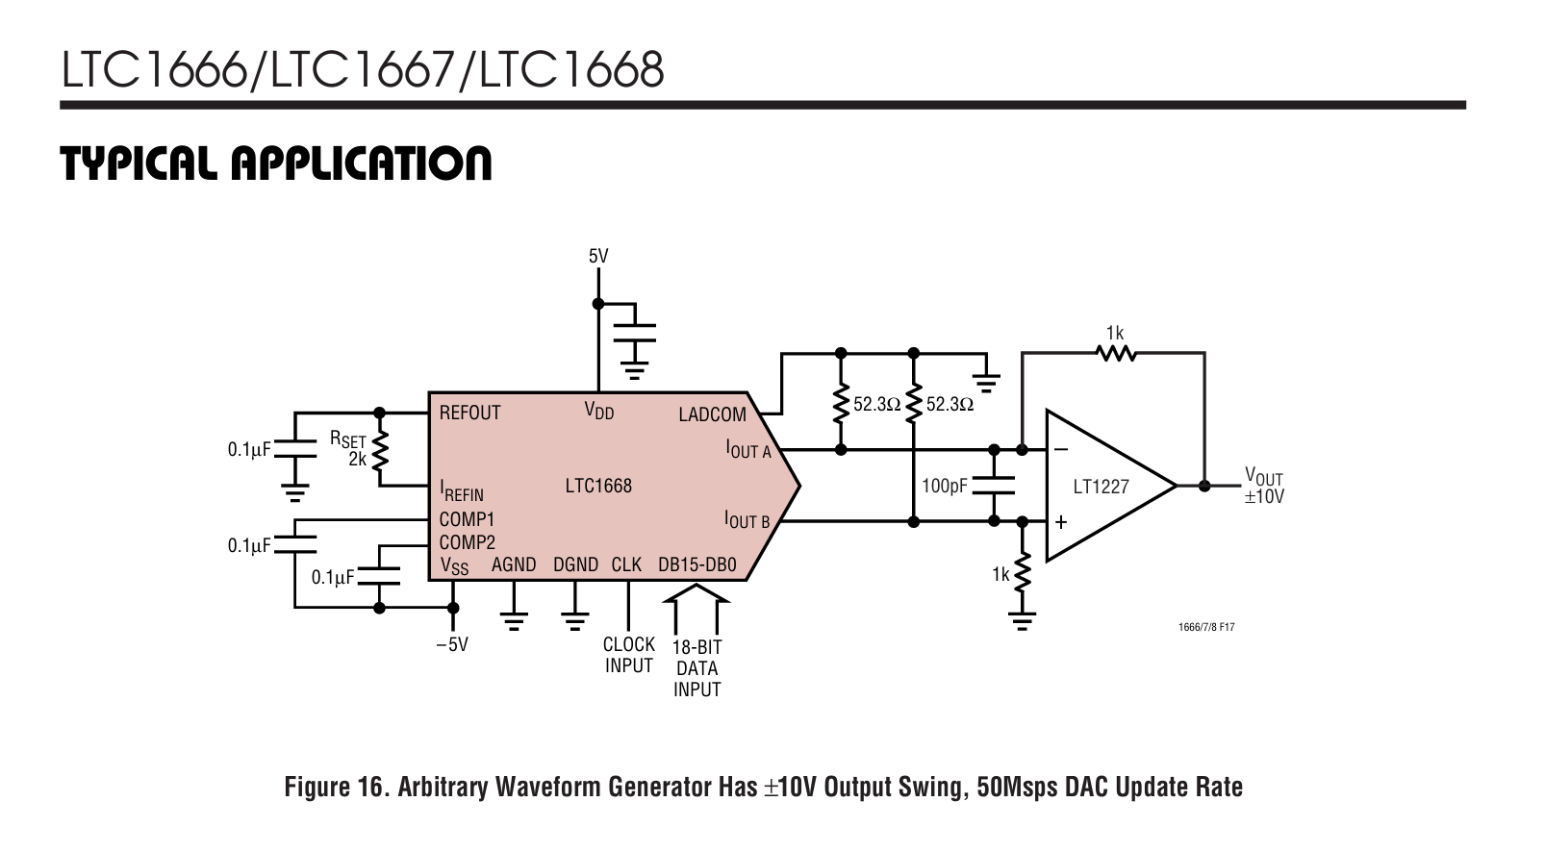

Schedule

Week 1 (Now – Sept 15)
- Finalize Requirements
  - Decide on wireless protocol (Wi-Fi vs BLE vs Bluetooth Classic).
  - Confirm communication method with FPGA/DDS (SPI, UART, etc.).
  - Define parameters to be sent/received (frequency, amplitude, waveform type, status, etc.).
- Select Hardware
  - Pick the MCU dev board (e.g., ESP32 DevKitC, STM32 Nucleo, Arduino Nano 33 IoT).
  - Order supporting parts (power regulators, headers, cables, programmer if needed).

Week 2–3 (Sept 16 – Sept 30)
- Basic MCU Setup
  - Install toolchain (Arduino IDE, PlatformIO, STM32CubeIDE, depending on board).
  - Blink test, GPIO test, ensure programming works.
- Wireless Communication
  - Implement simple app → MCU message exchange (e.g., send “hello” from phone, MCU replies).
  - Verify stable wireless link.

Week 4–5 (Oct 1 – Oct 15)
- Subsystem Communication
  - Implement SPI/UART link to FPGA or dummy peripheral.
  - Define and test protocol for sending tuning words and waveform codes.
  - Create MCU-side functions to convert frequency → tuning word, amplitude → scaling word.
- Debugging Tools
  - Add serial debug output.
  - Optional: add LEDs or small display for status.

Week 6–7 (Oct 16 – Oct 31)
- Integration Stage 1
  - MCU talks to FPGA/DDS testbench.
  - Verify frequency changes work correctly.
  - Verify waveform selection works.
  - Ensure status/error feedback is passed back to MCU.
- Mobile App Tie-in
  - Simple UI for phone (dropdown waveform, sliders for freq/amplitude).
  - Confirm MCU properly updates FPGA/DDS based on phone input.

Week 8 (Nov 1 – Nov 10)
- System Polishing
  - Add error handling (invalid values, wireless disconnect, FPGA busy flag).
  - Optimize code structure (separate wireless handler, FPGA handler, command parser).
  - Optional: implement preset storage (save settings in flash/EEPROM).
- Full Subsystem Demo

Links and Tables
Amazon Link - https://www.amazon.com/ESP-WROOM-32-Development-Microcontroller-Integrated-Compatible/dp/B08D5ZD528/ref=sr_1_3?crid=1JU3LZ5Z06U5E&dib=eyJ2IjoiMSJ9.XBINg-sjhfF_gUtnMiKGjsLiCuLEycgdFrmL8VVYvRcjPqftwWvnVGchMl2Ii6Av7PrDLSbNpuqZJfsmYdnzoCBPR3qAhnuZ-6-tNewAZz_VZ0CjPS14jD-3XvJZ9Lx1qIzcdVHeYC3s8g_EjgmpTeVmpgFGeI_bbGfPjD8URNapEZ--Wfur5hCFfuFC3VLLBW4o1kSeqWihAB1JXyBKTkSlJdGmwU7hwKPYDxilXk0.4VG3pRBIv-oNnrUYSzY3y6WMchIayAn_yVONdcTc1UY&dib_tag=se&keywords=esp32&qid=1757103596&sprefix=esp32%2Caps%2C131&sr=8-3&th=1

ESP32 Datasheet - https://www.espressif.com/sites/default/files/documentation/esp32-wroom-32_datasheet_en.pdf

ESP32 DevKit Datasheet -
https://docs.espressif.com/projects/esp-dev-kits/en/latest/esp32/esp32-devkitc/index.html

Parameter | Purpose | Where to Find It | Value
Core Voltage | Power | https://www.espressif.com/sites/default/files/documentation/esp32-wroom-32_datasheet_en.pdf | 3-3.6 (V)
Core Current (Max) | Power | Same | 0.5A minimum
I/O Voltage | Control | Same | VDD
Any Special Rails

ESP32 VSCODE Setup and Blinking LED
https://www.youtube.com/watch?v=WxELHnnlBmU

